1. Autoship Pause Email

[](https://www.laballey.com/)

Hi Samantha,   
Your next Lab Alley autoship delivery has been Paused.

Thu, Jan 01

To restart your shipment, just click the button below to update your delivery frequency

Items in this delivery:

**Hazmat Fee - Required**



**Ethanol 190 Proof (95%) Certified Organic/Vegan Sugarcane Alcohol, FCC Grade**

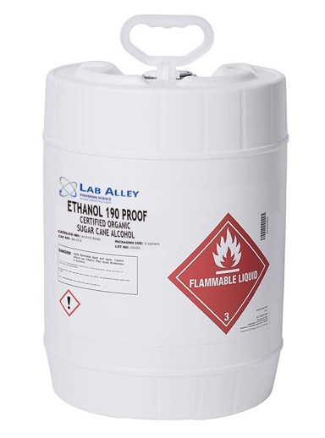

Ship to:

2797 NW Clearwater Drive Suite 100 ,Bend ,97703 Oregon

Estimated total:

|  |  |
| --- | --- |
| Subtotal | $365.00 |
| Shipping | $35.00 |
| Discount | $18.00 |
| Order total | $382.00 |

[Manage Your Delivery](https://www.laballey.com/account/login)

**Lab Alley LLC**   
22111 Highway 71 West, Suite 601  
Spicewood, Texas 78669  
Phone: 512-668-9918  
[customerservice@laballey.com](mailto:customerservice@laballey.com)

1. Autoship Skip Email

[](https://www.laballey.com/)

Hi Samantha,   
Your next Lab Alley autoship delivery has been skipped

Sun, Apr 09

Items in this delivery:

**Hazmat Fee - Required**



**Ethanol 190 Proof (95%) Certified Organic/Vegan Sugarcane Alcohol, FCC Grade**

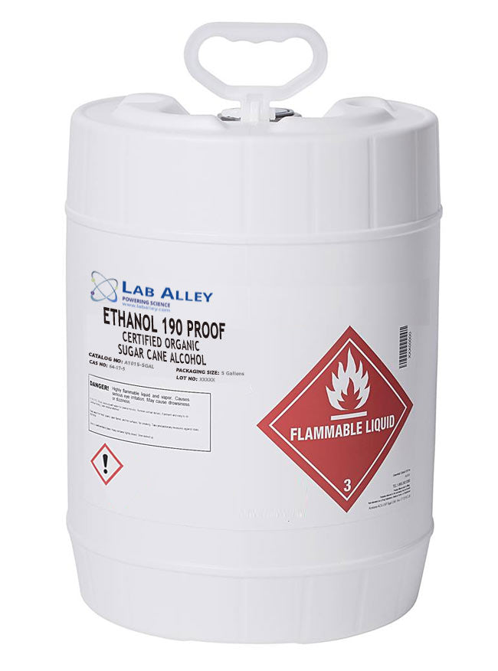

Ship to:

2797 NW Clearwater Drive Suite 100 ,Bend ,97703 Oregon

Estimated total:

|  |  |
| --- | --- |
| Subtotal | $365.00 |
| Shipping | $35.00 |
| Discount | $18.00 |
| Order total | $382.00 |

[Manage Your Delivery](https://www.laballey.com/account/login)

**Lab Alley LLC**   
22111 Highway 71 West, Suite 601  
Spicewood, Texas 78669  
Phone: 512-668-9918  
[customerservice@laballey.com](mailto:customerservice@laballey.com)

1. . Autoship Pause Email

[](https://www.laballey.com/)

Hi Justin,   
your next autoship delivery is estimated to arrive by:

Fri, Sep 10

Items in this delivery:

**SDA-40B Ethanol 200 Proof (100%)**

**Hazmat Fee - Required**



**SDA-40B Ethanol 200 Proof (100%)**

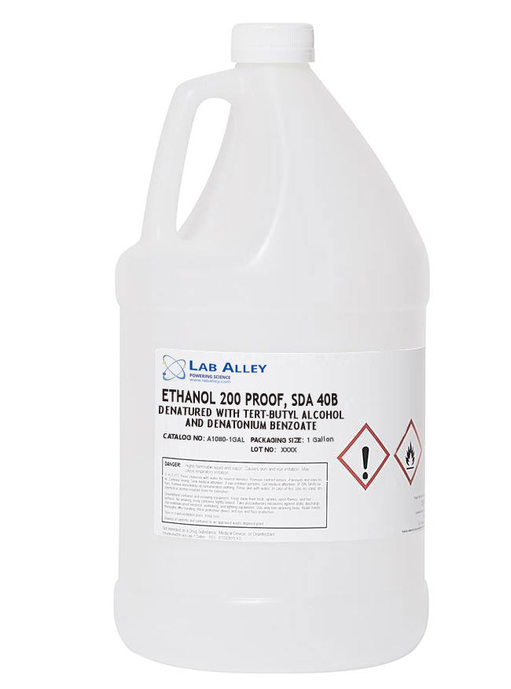

**Hazmat Fee - Required**



Ship to:

2312 Highland Parc Place Se ,Marietta ,30067 Georgia

Estimated total:

|  |  |
| --- | --- |
| Subtotal | $640.00 |
| Shipping | $19.00 |
| Discount | $32.00 |
| Order total | $627.00 |

[Manage Your Delivery](https://www.laballey.com/account/login)

**Lab Alley LLC**   
22111 Highway 71 West, Suite 601  
Spicewood, Texas 78669  
Phone: 512-668-9918  
[customerservice@laballey.com](mailto:customerservice@laballey.com)

Subject: Action required! Your payment has been declined.

Email: Your payment for your subscription did not go through.

Please update your billing information before your subscription expires.